**PRUEBAS 5017**

SE REALIZAN PRUEBAS DE ESTE REQUERIMIENTO A UNQUE ESTE NO APLIQUE PARA GASES DEL CARIBE, SE TOMA COMO REFERENCIA EL MES DE MAYO PARA REALIZAR ESTA, EL RESULTADO DEBE SER IGUAL AL OBTENIDO EN SU MOMENTO, NO DEBE HABER VARIACION DEL DOCUMENTO GENERADO, PERO COMO ESTA EL REQUERIMIENTO 6749 QUE CORRIGE LAS VENTAS DE BRILLA Y EL NUMERO DE REGISTROS POR DOCUMENTO, 2 BRILLA, SE VA A REFLEJAR UNA DIFERENCIA QUE HUBO EN MAYO QUE SE CORRIGE AHORA Y ESTO ESTA BIEN QUE SE PRESENTE POR LA CORRRECION DEL REQUERIMIENTO EN MENCION.

1. SE REVERSAN LOS REGISTROS CONTABLES GENERADOS PARA LOS 6 COMPROBANTES QUE SE TIENEN.

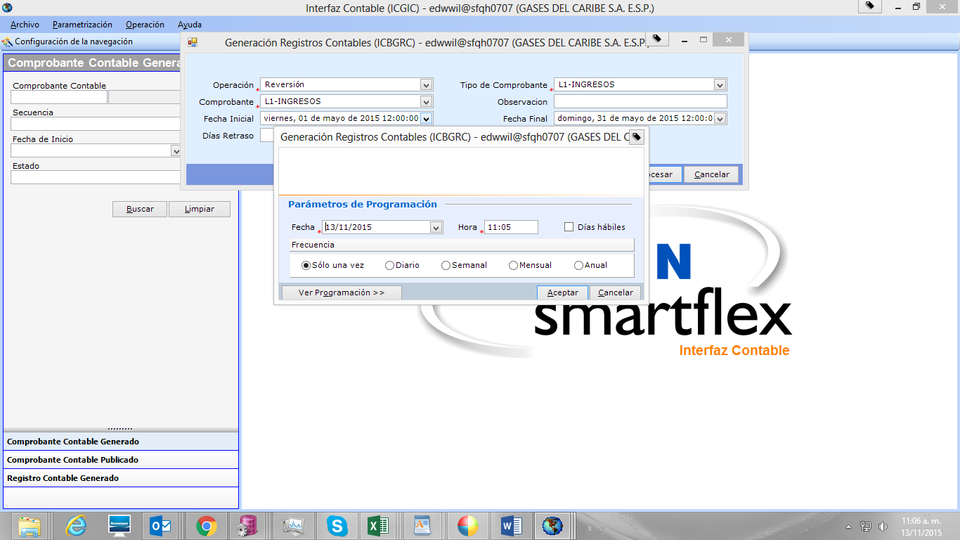

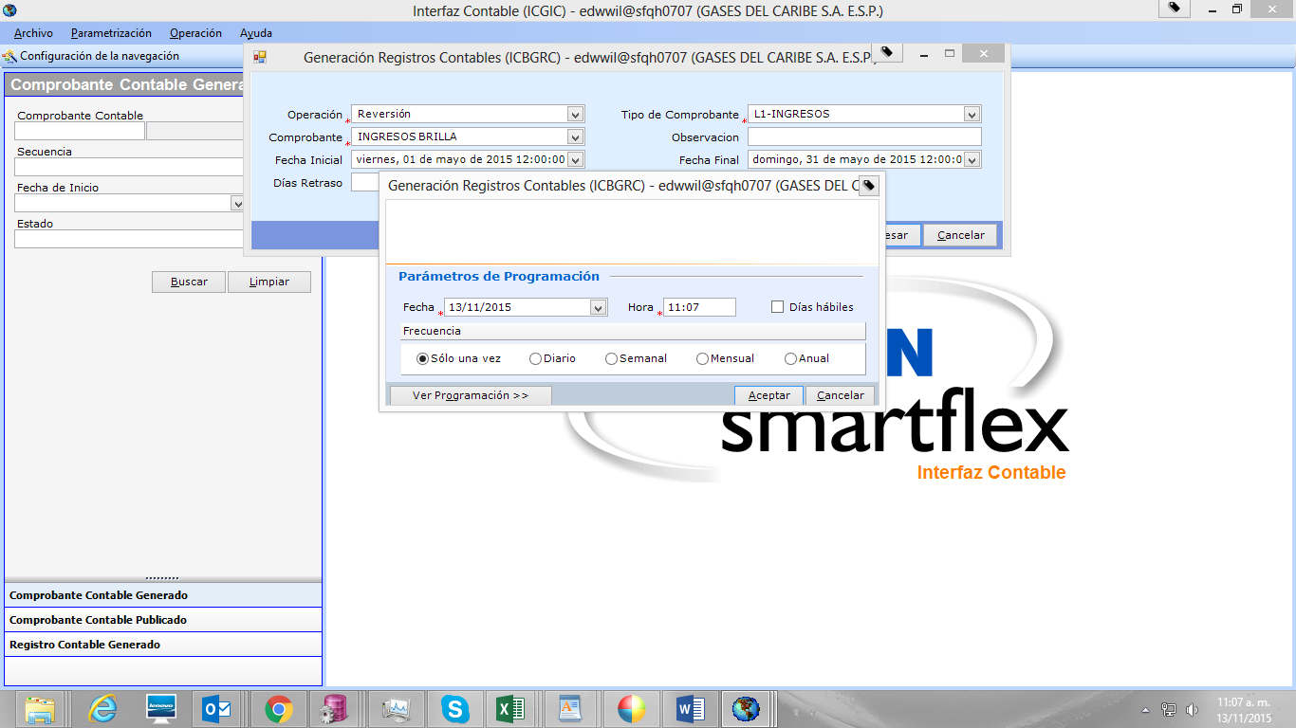

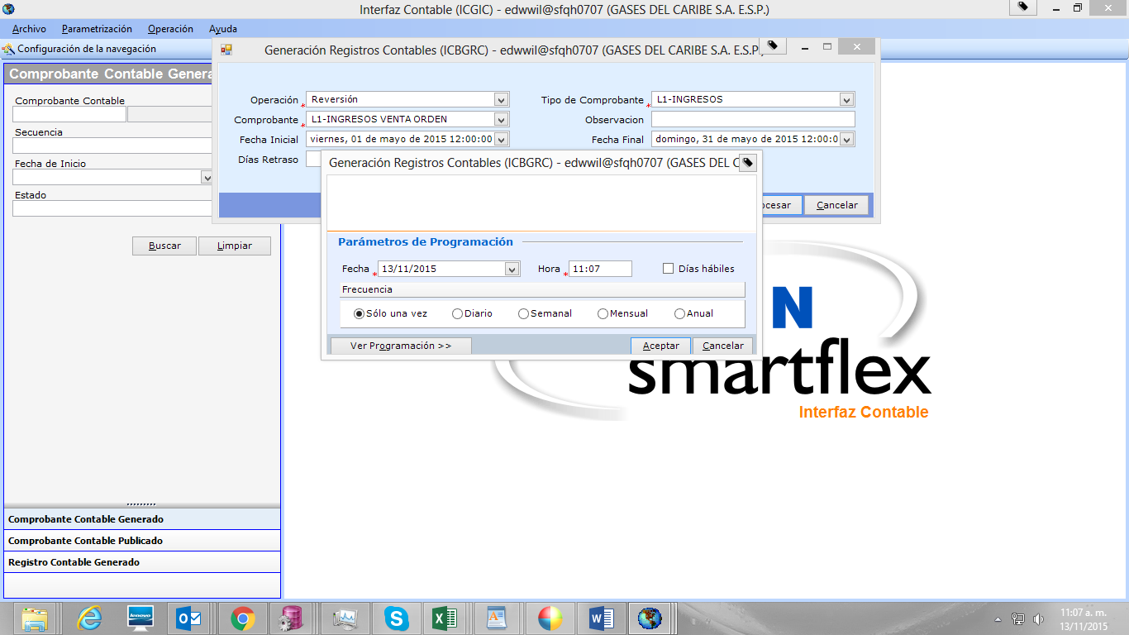

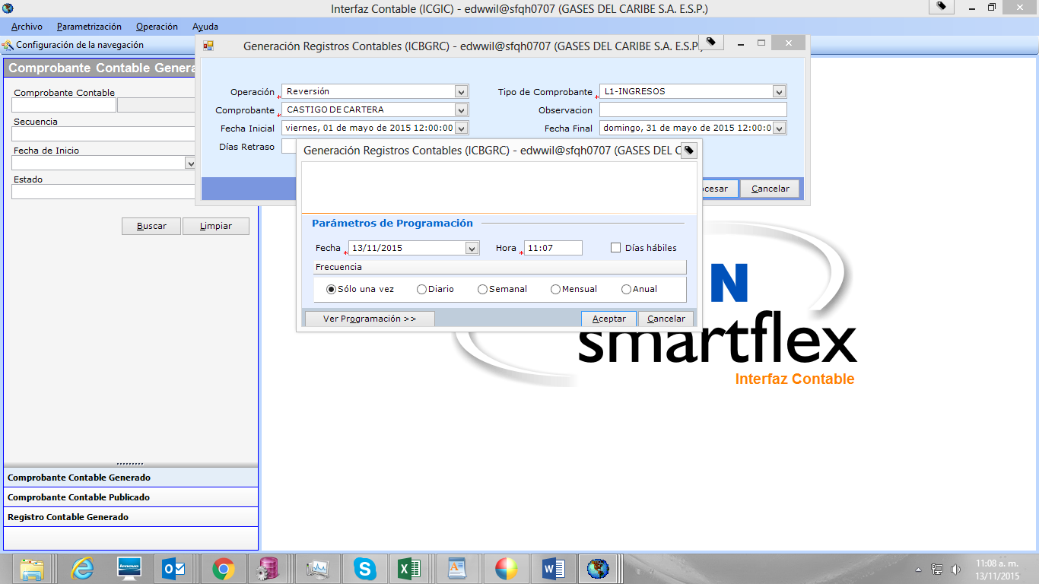

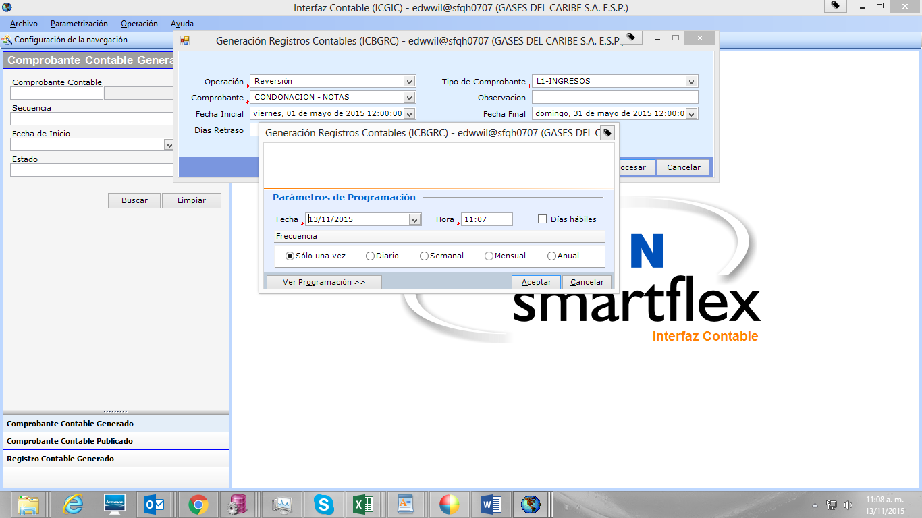

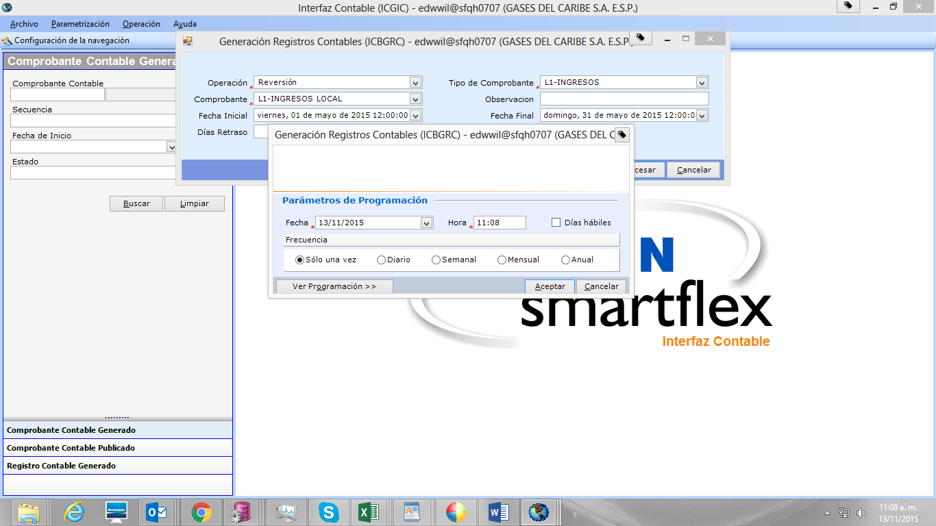

1. SE GENEREAN LOS REGISTROS CONTABLES PARA LOS MISMOS COMPROBANTES

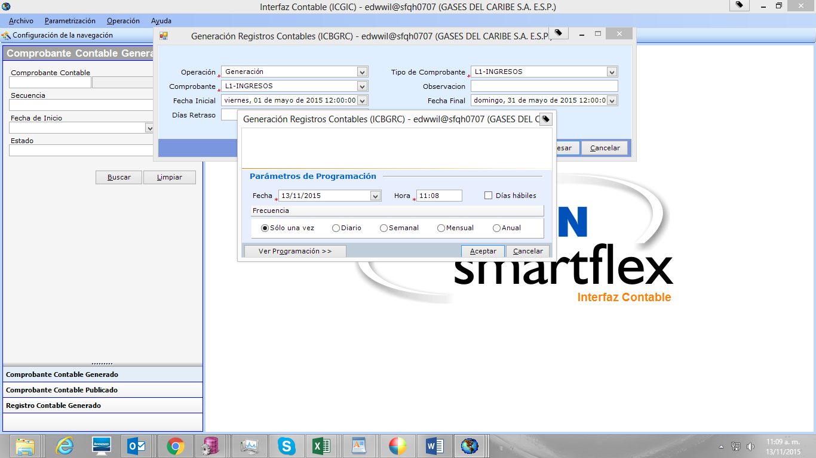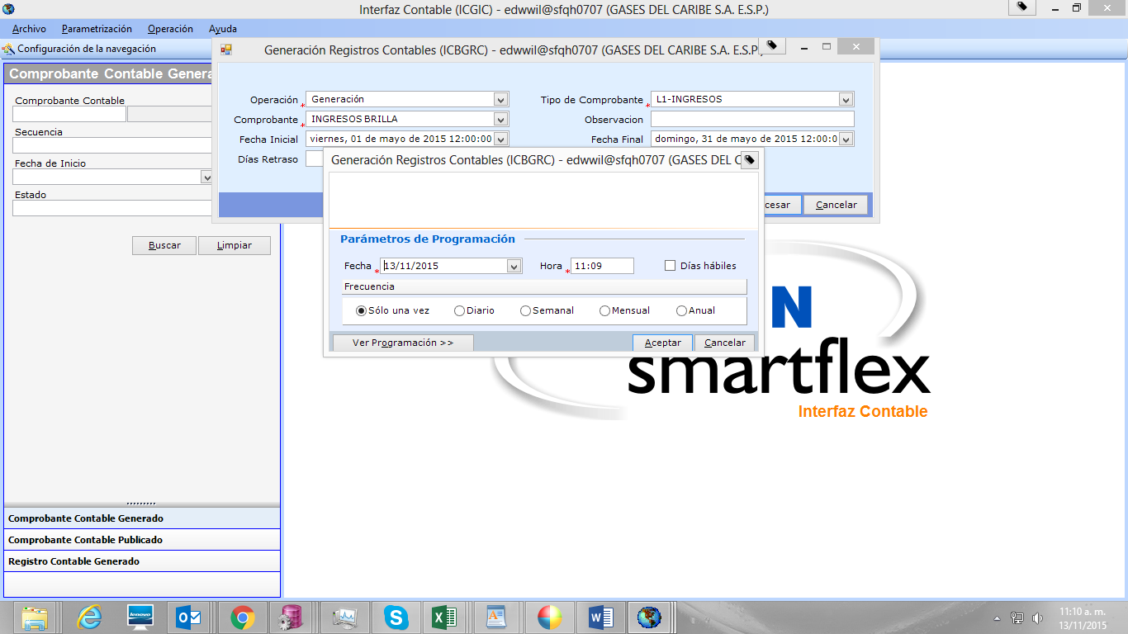

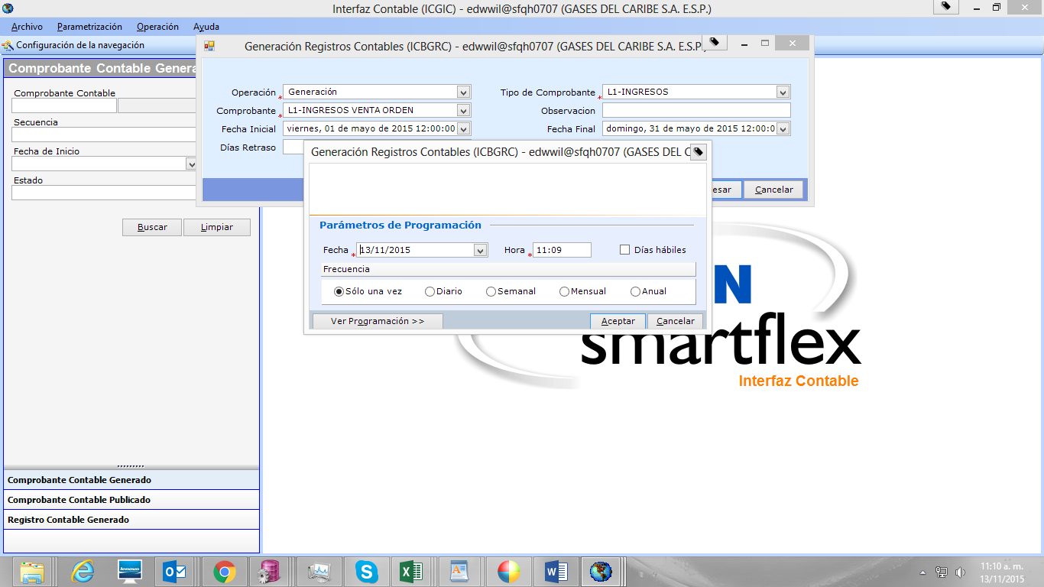

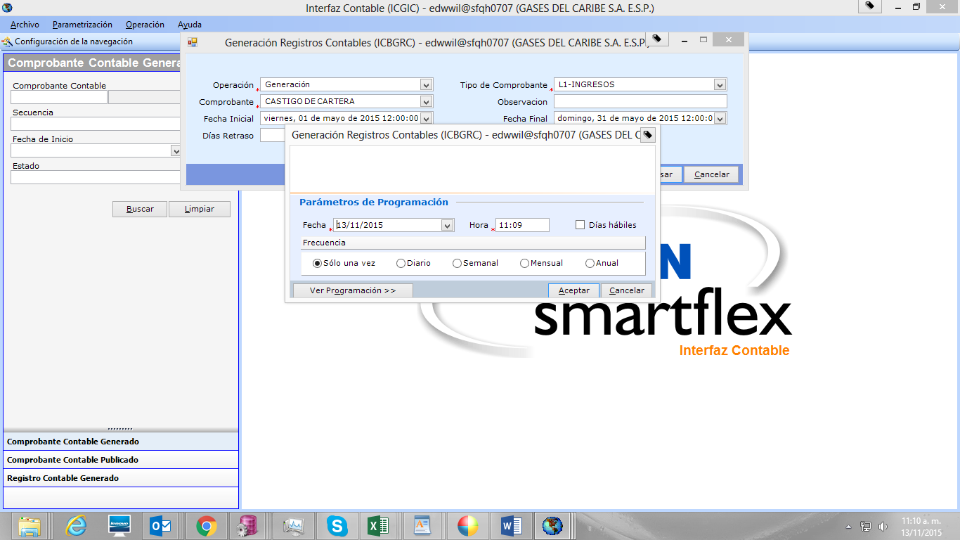

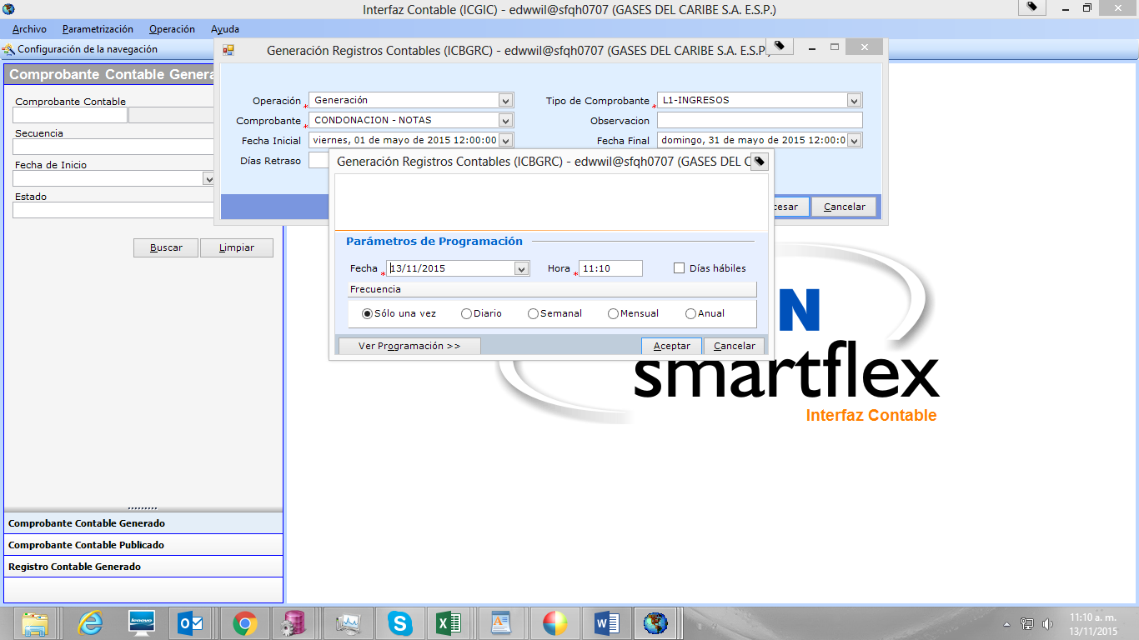

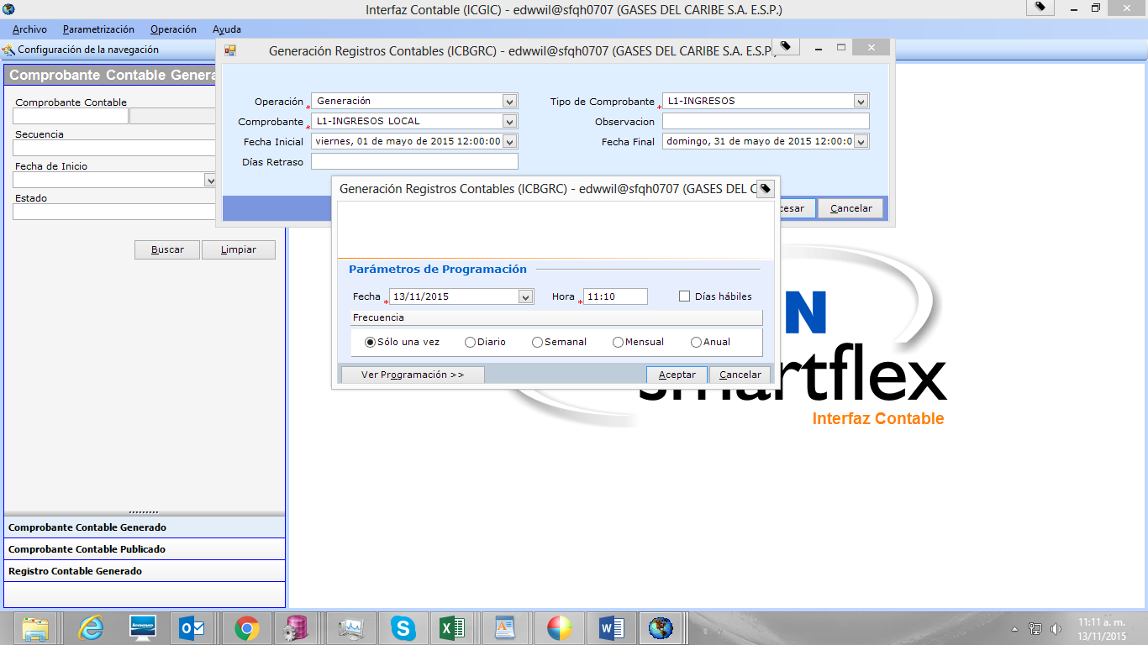

VERIFICACION PROCESO DE GENERACION Y REVERSION REGISTROS CONTABLES

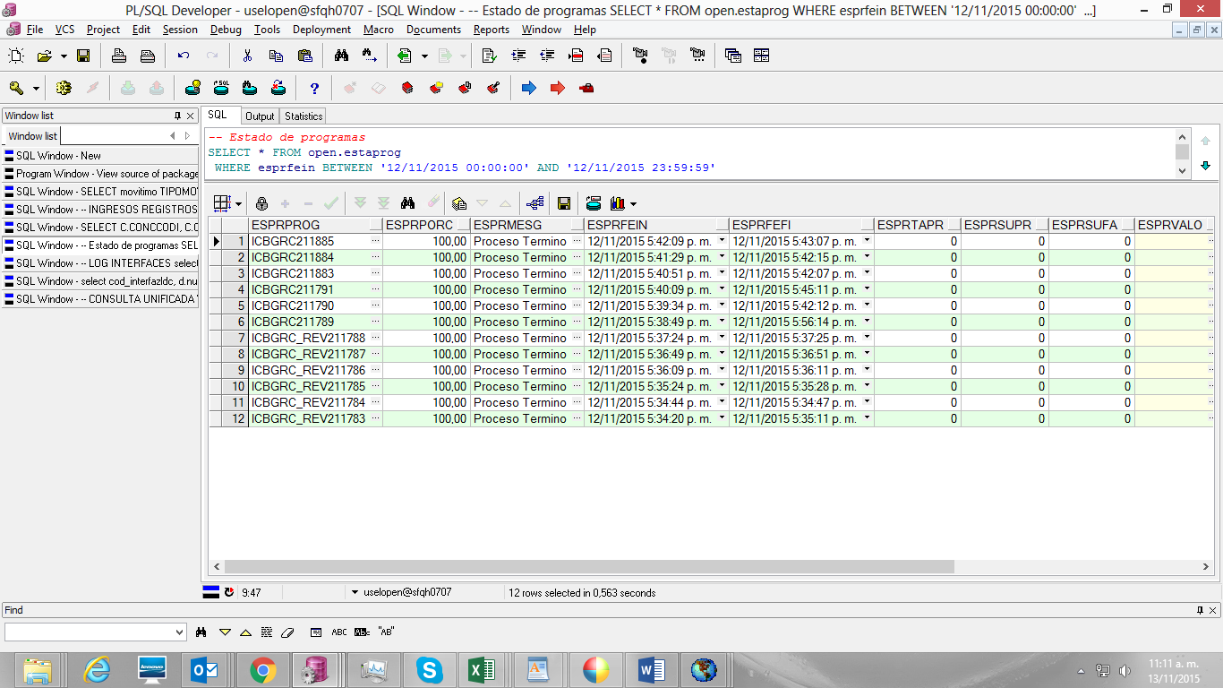

1. GENERACION TRAMA INTERFAZ DE INGRESOS

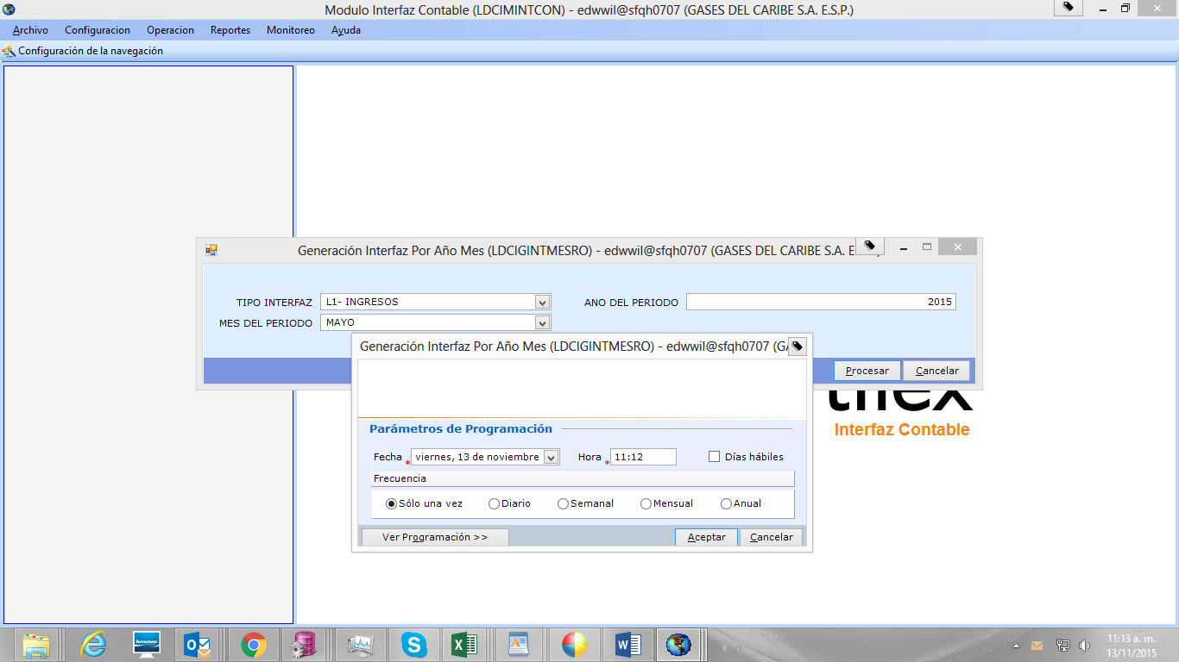

1. SE VERIFICA QUE SE HAYA GENERO LA NUEVA TRAMA

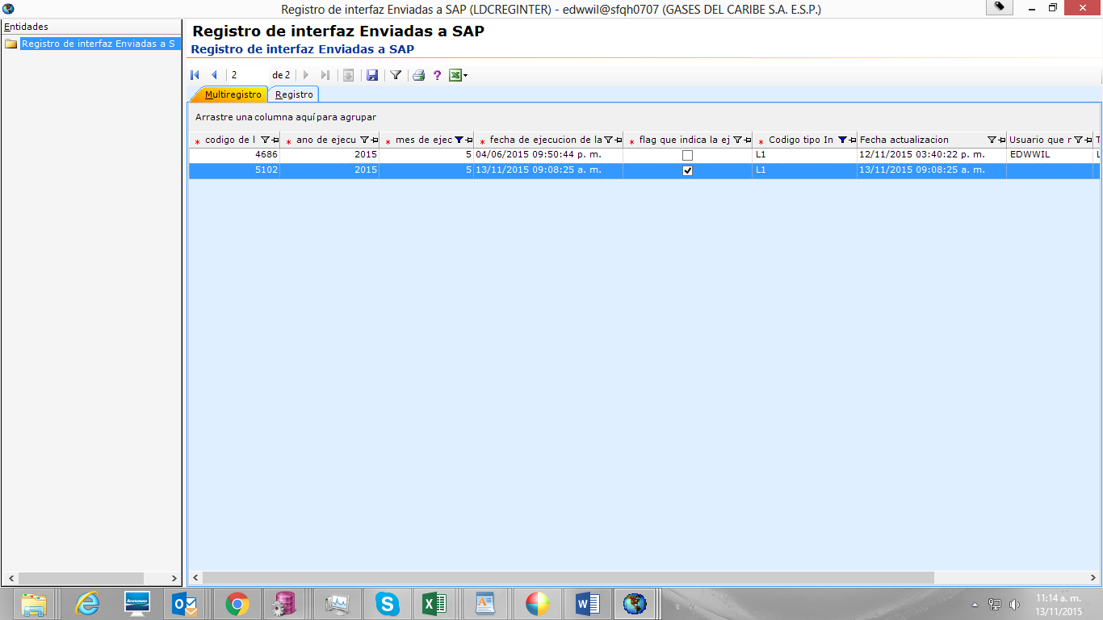

1. HACEMOS VALIDACION DE LA INTERFA REAL GENERADA EN MAYO CON LA INTERFA REALIZADA EN PRUEBAS, POR NUMERO DE TRAMA, NÚMERO DE CLASIFICADOR, Y CUENTAS CONTABLES.

PARA ELLO UTILIZAMOS LA SIGUIENTE CONSULTA;

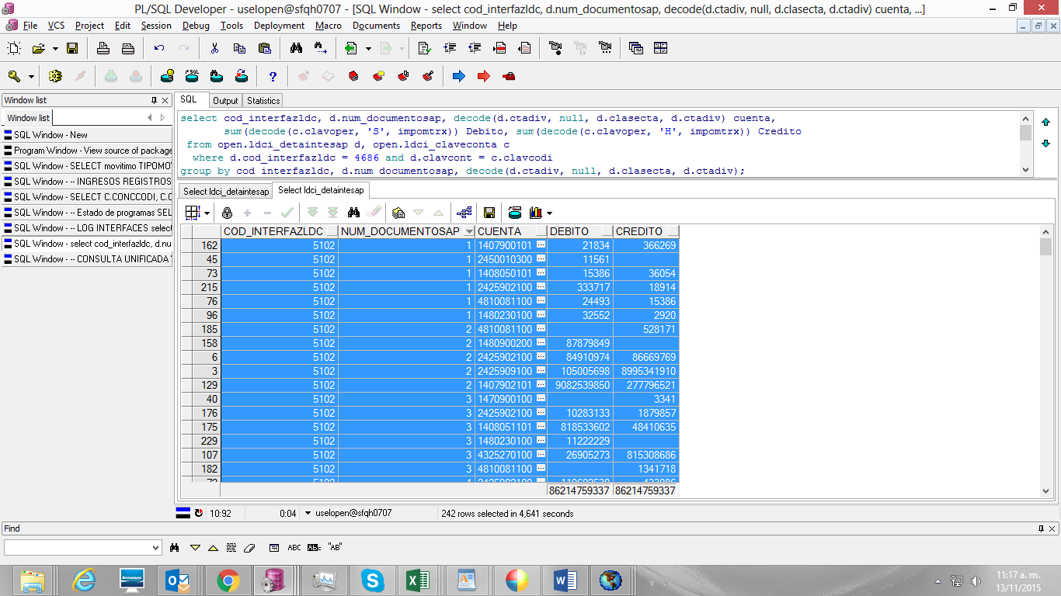

1. SE VALIDA EL RESULTADO OBTENIDO

|  |  |  |  |  |  |  |  |  |  |
| --- | --- | --- | --- | --- | --- | --- | --- | --- | --- |
| **INTERFAZ GENERADA EN MAYO TRAMA 4686** | | | | **INTERFAZ GENERADA PRUEBA 5102** | | | | **DIFERENCIAS** | |
| **DTO** | **CUENTA** | **DEBITO** | **CREDITO** | **DTO** | **CUENTA** | **DEBITO** | **CREDITO** | **DEBITO** | **CREDITO** |
| 1 | 1407900101 | 21.834 | 366.269 | 1 | 1407900101 | 21.834 | 366.269 | - | - |
| 1 | 1408050101 | 15.386 | 36.054 | 1 | 1408050101 | 15.386 | 36.054 | - | - |
| 1 | 1480230100 | 32.552 | 2.920 | 1 | 1480230100 | 32.552 | 2.920 | - | - |
| 1 | 2425902100 | 333.717 | 18.914 | 1 | 2425902100 | 333.717 | 18.914 | - | - |
| 1 | 2450010300 | 11.561 |  | 1 | 2450010300 | 11.561 |  | - | - |
| 1 | 4810081100 | 24.493 | 15.386 | 1 | 4810081100 | 24.493 | 15.386 | - | - |
| 2 | 1407902101 | 11.468.278.979 | 277.796.521 | 2 | 1407902101 | 9.082.539.850 | 277.796.521 | 2.385.739.129 | - |
| 2 | 1480900200 | 87.879.849 |  | 2 | 1480900200 | 87.879.849 |  | - | - |
| 2 | 2425902100 | 84.910.974 | 86.669.769 | 2 | 2425902100 | 84.910.974 | 86.669.769 | - | - |
| 2 | 2425909100 | 105.005.698 | 11.381.081.039 | 2 | 2425909100 | 105.005.698 | 8.995.341.910 | - | 2.385.739.129 |
| 2 | 4810081100 |  | 528.171 | 2 | 4810081100 |  | 528.171 | - | - |
| 3 | 1408051101 | 818.533.602 | 48.410.635 | 3 | 1408051101 | 818.533.602 | 48.410.635 | - | - |
| 3 | 1470900100 |  | 3.341 | 3 | 1470900100 |  | 3.341 | - | - |
| 3 | 1480230100 | 11.222.229 |  | 3 | 1480230100 | 11.222.229 |  | - | - |
| 3 | 2425902100 | 10.283.133 | 1.879.857 | 3 | 2425902100 | 10.283.133 | 1.879.857 | - | - |
| 3 | 4325270100 | 26.905.273 | 815.308.686 | 3 | 4325270100 | 26.905.273 | 815.308.686 | - | - |
| 3 | 4810081100 |  | 1.341.718 | 3 | 4810081100 |  | 1.341.718 | - | - |
| 4 | 1408050101 | 817.849.246 | 145.215.488 | 4 | 1408050101 | 817.849.246 | 145.215.488 | - | - |
| 4 | 1480230100 | 20.540.846 |  | 4 | 1480230100 | 20.540.846 |  | - | - |
| 4 | 2425902100 | 119.602.530 | 433.086 | 4 | 2425902100 | 119.602.530 | 433.086 | - | - |
| 4 | 2915030000 | 5.072.112 | 806.119.243 | 4 | 2915030000 | 5.072.112 | 806.119.243 | - | - |
| 4 | 4810081100 |  | 11.296.917 | 4 | 4810081100 |  | 11.296.917 | - | - |
| 6 | 1407900101 | 4.848 | 15.894 | 6 | 1407900101 | 4.848 | 15.894 | - | - |
| 6 | 1480230100 |  | 4.848 | 6 | 1480230100 |  | 4.848 | - | - |
| 6 | 4810081100 | 15.894 |  | 6 | 4810081100 | 15.894 |  | - | - |
| 7 | 1408051101 | 53.101.510.091 | 2.038.357.501 | 7 | 1408051101 | 53.101.510.091 | 2.038.357.501 | - | - |
| 7 | 1470900100 |  | 23.124.766 | 7 | 1470900100 |  | 23.124.766 | - | - |
| 7 | 1480230100 | 79.248.726 | 840.593 | 7 | 1480230100 | 79.248.726 | 840.593 | - | - |
| 7 | 2425902100 | 962.089.467 | 47.580.143 | 7 | 2425902100 | 962.089.467 | 47.580.143 | - | - |
| 7 | 4325270200 | 196.410.325 | 53.016.326.569 | 7 | 4325270200 | 196.410.325 | 53.016.326.569 | - | - |
| 7 | 4810081100 | 188.306 | 13.538.020 | 7 | 4810081100 | 188.306 | 13.538.020 | - | - |
| 7 | 4810470100 | 800.420.677 | 100.000 | 7 | 4810470100 | 800.420.677 | 100.000 | - | - |
| 8 | 1408051101 | 632.688.443 | 48.332.622 | 8 | 1408051101 | 632.688.443 | 48.332.622 | - | - |
| 8 | 1470900100 |  | 53.378 | 8 | 1470900100 |  | 53.378 | - | - |
| 8 | 1480230100 | 5.907.454 | 15.920 | 8 | 1480230100 | 5.907.454 | 15.920 | - | - |
| 8 | 2425902100 | 5.642.033 | 3.631.328 | 8 | 2425902100 | 5.642.033 | 3.631.328 | - | - |
| 8 | 2430152100 | 1.465.700 | 154.888.898 | 8 | 2430152100 | 1.465.700 | 154.888.898 | - | - |
| 8 | 2430152300 | 1.987.311 | 310.182 | 8 | 2430152300 | 1.987.311 | 310.182 | - | - |
| 8 | 2430152400 | 2.100.481 | 262.227.086 | 8 | 2430152400 | 2.100.481 | 262.227.086 | - | - |
| 8 | 2430152500 | 31.229.643 | 211.140.246 | 8 | 2430152500 | 31.229.643 | 211.140.246 | - | - |
| 8 | 4810081100 |  | 421.405 | 8 | 4810081100 |  | 421.405 | - | - |
| 10 | 1407900101 | 15.524.013 | 27.509.487 | 10 | 1407900101 | 15.524.013 | 27.509.487 | - | - |
| 10 | 4395900103 | 27.509.487 | 15.524.013 | 10 | 4395900103 | 27.509.487 | 15.524.013 | - | - |
| 17 | 1408050101 | 870.863.269 | 45.634.778 | 17 | 1408050101 | 870.863.269 | 45.634.778 | - | - |
| 17 | 1480230100 | 37.667.122 | 855 | 17 | 1480230100 | 37.667.122 | 855 | - | - |
| 17 | 2425902100 | 3.187.228 | 1.263.292 | 17 | 2425902100 | 3.187.228 | 1.263.292 | - | - |
| 17 | 4325260500 | 4.780.428 | 858.850.719 | 17 | 4325260500 | 4.780.428 | 858.850.719 | - | - |
| 17 | 4810081100 |  | 10.748.403 | 17 | 4810081100 |  | 10.748.403 | - | - |
| 19 | 1407900101 | 1.311.459.957 | 112.446.704 | 19 | 1407900101 | 1.311.459.957 | 112.446.704 | - | - |
| 19 | 2425902100 | 112.048.970 |  | 19 | 2425902100 | 112.048.970 |  | - | - |
| 19 | 2915030000 | 397.734 | 1.311.459.957 | 19 | 2915030000 | 397.734 | 1.311.459.957 | - | - |
| 21 | 1408051101 | 12.468 | 14.846 | 21 | 1408051101 | 12.468 | 14.846 | - | - |
| 21 | 1480230100 |  | 12.468 | 21 | 1480230100 |  | 12.468 | - | - |
| 21 | 4810081100 | 14.846 |  | 21 | 4810081100 | 14.846 |  | - | - |
| 22 | 1408050101 | 792.000 | 201.828 | 22 | 1408050101 | 792.000 | 201.828 | - | - |
| 22 | 2425902100 | 3.828 |  | 22 | 2425902100 | 3.828 |  | - | - |
| 22 | 4325260600 | 198.000 | 792.000 | 22 | 4325260600 | 198.000 | 792.000 | - | - |
| 24 | 1407901101 | 1.538.188 | 11.016.515 | 24 | 1407901101 | 1.538.188 | 11.016.515 | - | - |
| 24 | 1480230100 | 7.253.235 |  | 24 | 1480230100 | 7.253.235 |  | - | - |
| 24 | 2425902100 | 3.318.460 | 75.070 | 24 | 2425902100 | 3.318.460 | 75.070 | - | - |
| 24 | 4390900110 | 444.820 | 7.938 | 24 | 4390900110 | 444.820 | 7.938 | - | - |
| 24 | 4810081100 |  | 1.455.180 | 24 | 4810081100 |  | 1.455.180 | - | - |
| 27 | 1407901101 | 244.392.554 | 74.959.516 | 27 | 1407901101 | 244.392.554 | 74.959.516 | - | - |
| 27 | 1480230100 | 58.088.610 |  | 27 | 1480230100 | 58.088.610 |  | - | - |
| 27 | 2425902100 | 5.561.370 | 1.826.018 | 27 | 2425902100 | 5.561.370 | 1.826.018 | - | - |
| 27 | 4390900102 | 11.309.536 | 221.338.503 | 27 | 4390900102 | 11.309.536 | 221.338.503 | - | - |
| 27 | 4810081100 |  | 21.228.033 | 27 | 4810081100 |  | 21.228.033 | - | - |
| 28 | 1408050101 | 236.161.270 | 20.418.996 | 28 | 1408050101 | 236.161.270 | 20.418.996 | - | - |
| 28 | 1480230100 | 11.981.576 |  | 28 | 1480230100 | 11.981.576 |  | - | - |
| 28 | 2425902100 | 2.857.999 | 694.119 | 28 | 2425902100 | 2.857.999 | 694.119 | - | - |
| 28 | 4325260400 | 5.579.421 | 230.168.671 | 28 | 4325260400 | 5.579.421 | 230.168.671 | - | - |
| 28 | 4810081100 |  | 5.298.480 | 28 | 4810081100 |  | 5.298.480 | - | - |
| 30 | 1408051101 | 47.034.306 | 5.182.437.544 | 30 | 1408051101 | 47.034.306 | 5.182.437.544 | - | - |
| 30 | 1480230100 | 228.657 | 7.182.757 | 30 | 1480230100 | 228.657 | 7.182.757 | - | - |
| 30 | 2425902100 | 326.243 | 21.529.285 | 30 | 2425902100 | 326.243 | 21.529.285 | - | - |
| 30 | 2430151100 | 5.178.534.238 | 18.238.929 | 30 | 2430151100 | 5.178.534.238 | 18.238.929 | - | - |
| 30 | 4810081100 | 3.348.406 | 83.335 | 30 | 4810081100 | 3.348.406 | 83.335 | - | - |
| 32 | 1406060101 | 64.277 | 98.958 | 32 | 1406060101 | 64.277 | 98.958 | - | - |
| 32 | 1480230100 | 98.418 |  | 32 | 1480230100 | 98.418 |  | - | - |
| 32 | 2425902100 | 540 |  | 32 | 2425902100 | 540 |  | - | - |
| 32 | 4810081100 |  | 64.277 | 32 | 4810081100 |  | 64.277 | - | - |
| 35 | 1408050101 | 4 |  | 35 | 1408050101 | 4 |  | - | - |
| 35 | 2425902100 |  | 4 | 35 | 2425902100 |  | 4 | - | - |
| 44 | 1407901101 |  | 152.700 | 44 | 1407901101 |  | 152.700 | - | - |
| 44 | 2425902100 | 152.700 |  | 44 | 2425902100 | 152.700 |  | - | - |
| 46 | 1408051101 | 10.419.280 | 89.639.625 | 46 | 1408051101 | 10.419.280 | 89.639.625 | - | - |
| 46 | 1470034101 | 300.765.641 |  | 46 | 1470034101 | 300.765.641 |  | - | - |
| 46 | 1470900100 |  | 8.475 | 46 | 1470900100 |  | 8.475 | - | - |
| 46 | 1480230100 | 59.975.294 |  | 46 | 1480230100 | 59.975.294 |  | - | - |
| 46 | 2425902100 | 1.089.913 | 374.388 | 46 | 2425902100 | 1.089.913 | 374.388 | - | - |
| 46 | 4805130201 | 20.373.557 | 301.382.026 | 46 | 4805130201 | 20.373.557 | 301.382.026 | - | - |
| 46 | 4810081100 | 6.358 | 9.420.032 | 46 | 4810081100 | 6.358 | 9.420.032 | - | - |
| 46 | 4810470100 | 8.194.503 |  | 46 | 4810470100 | 8.194.503 |  | - | - |
| 49 | 1408050101 |  | 323.799 | 49 | 1408050101 |  | 323.799 | - | - |
| 49 | 1408051101 | 15.894 |  | 49 | 1408051101 | 15.894 |  | - | - |
| 49 | 2425902100 | 323.799 |  | 49 | 2425902100 | 323.799 |  | - | - |
| 49 | 4810081100 |  | 15.894 | 49 | 4810081100 |  | 15.894 | - | - |
| 52 | 1407904101 | 486.658 | 6.109.695 | 52 | 1407904101 | 486.658 | 6.109.695 | - | - |
| 52 | 2425100100 | 6.080.942 | 134.380 | 52 | 2425100100 | 6.080.942 | 134.380 | - | - |
| 52 | 2425902100 | 28.753 | 352.278 | 52 | 2425902100 | 28.753 | 352.278 | - | - |
| 53 | 1407904101 |  | 233.225.366 | 53 | 1407904101 |  | 233.225.366 | - | - |
| 53 | 1407907101 | 420.266.036 |  | 53 | 1407907101 | 420.266.036 |  | - | - |
| 53 | 2425100100 | 233.225.366 | 420.192.336 | 53 | 2425100100 | 233.225.366 | 420.192.336 | - | - |
| 53 | 2425902100 |  | 73.700 | 53 | 2425902100 |  | 73.700 | - | - |
| 56 | 1470037101 | 1.519.767.032 | 282.148.027 | 56 | 1470037101 | 1.519.767.032 | 282.148.027 | - | - |
| 56 | 1480230100 | 275.243.211 | 1 | 56 | 1480230100 | 275.243.211 | 1 | - | - |
| 56 | 2425902100 | 6.178.313 | 230.674 | 56 | 2425902100 | 6.178.313 | 230.674 | - | - |
| 56 | 4390900308 | 726.503 | 1.465.787.526 | 56 | 4390900308 | 726.503 | 1.465.787.526 | - | - |
| 56 | 4810081100 |  | 53.748.831 | 56 | 4810081100 |  | 53.748.831 | - | - |
| 58 | 1470031101 | 1.517.625.855 | 7.002.883 | 58 | 1470031101 | 1.517.625.855 | 7.002.883 | - | - |
| 58 | 1480230100 | 2.836.165 |  | 58 | 1480230100 | 2.836.165 |  | - | - |
| 58 | 2425902100 | 2.685.079 | 623.950 | 58 | 2425902100 | 2.685.079 | 623.950 | - | - |
| 58 | 4390900301 |  | 1.516.811.263 | 58 | 4390900301 |  | 1.516.811.263 | - | - |
| 58 | 4390900303 | 1.481.639 | 56.369 | 58 | 4390900303 | 1.481.639 | 56.369 | - | - |
| 58 | 4810081100 |  | 134.273 | 58 | 4810081100 |  | 134.273 | - | - |
| 59 | 1470034101 | 32.019.159 | 182.975 | 59 | 1470034101 | 32.019.159 | 182.975 | - | - |
| 59 | 2425902100 | 175.056 | 747 | 59 | 2425902100 | 175.056 | 747 | - | - |
| 59 | 4390900307 | 7.919 | 32.018.412 | 59 | 4390900307 | 7.919 | 32.018.412 | - | - |
| 60 | 1407906101 | 50.177.066 | 267.318 | 60 | 1407906101 | 50.177.066 | 267.318 | - | - |
| 60 | 1480230100 | 110.411 |  | 60 | 1480230100 | 110.411 |  | - | - |
| 60 | 2425902100 | 114.184 | 15.514 | 60 | 2425902100 | 114.184 | 15.514 | - | - |
| 60 | 2425909100 | 42.723 | 50.156.578 | 60 | 2425909100 | 42.723 | 50.156.578 | - | - |
| 60 | 4810081100 |  | 4.974 | 60 | 4810081100 |  | 4.974 | - | - |
| 62 | 1408051101 | 2.334.794.411 | 312.595.062 | 62 | 1408051101 | 2.334.794.411 | 312.595.062 | - | - |
| 62 | 1470900100 |  | 2.114.661 | 62 | 1470900100 |  | 2.114.661 | - | - |
| 62 | 2425902100 | 81.511.460 | 3.156.569 | 62 | 2425902100 | 81.511.460 | 3.156.569 | - | - |
| 62 | 4325270200 | 11.031.701 | 2.329.523.181 | 62 | 4325270200 | 11.031.701 | 2.329.523.181 | - | - |
| 62 | 4810470100 | 220.051.901 |  | 62 | 4810470100 | 220.051.901 |  | - | - |
| 69 | 1408050101 | 5.000.000 | 5.000.000 | 69 | 1408050101 | 5.000.000 | 5.000.000 | - | - |
| 69 | 1470900100 |  | 5.000.000 | 69 | 1470900100 |  | 5.000.000 | - | - |
| 69 | 2425902100 | 5.000.000 |  | 69 | 2425902100 | 5.000.000 |  | - | - |
| 81 | 1407901101 | 22.693.585 | 5.320.491 | 81 | 1407901101 | 22.693.585 | 5.320.491 | - | - |
| 81 | 1480230100 | 4.726.489 |  | 81 | 1480230100 | 4.726.489 |  | - | - |
| 81 | 2425902100 | 467.202 |  | 81 | 2425902100 | 467.202 |  | - | - |
| 81 | 4390900102 | 126.800 | 21.929.004 | 81 | 4390900102 | 126.800 | 21.929.004 | - | - |
| 81 | 4810081100 |  | 764.581 | 81 | 4810081100 |  | 764.581 | - | - |
| 85 | 1408051101 | 113.264 | 3.545.517 | 85 | 1408051101 | 113.264 | 3.545.517 | - | - |
| 85 | 2425902100 |  | 113.264 | 85 | 2425902100 |  | 113.264 | - | - |
| 85 | 5101300200 | 3.545.517 |  | 85 | 5101300200 | 3.545.517 |  | - | - |
| 86 | 1470037101 | 5.129.633 | 35.944 | 86 | 1470037101 | 5.129.633 | 35.944 | - | - |
| 86 | 2425902100 | 29.234 | 627 | 86 | 2425902100 | 29.234 | 627 | - | - |
| 86 | 4390900308 | 6.710 |  | 86 | 4390900308 | 6.710 |  | - | - |
| 86 | 4390900315 |  | 5.129.006 | 86 | 4390900315 |  | 5.129.006 | - | - |
| 88 | 1470035101 | 119.546 | 891.697 | 88 | 1470035101 | 119.546 | 891.697 | - | - |
| 88 | 2425902100 | 891.697 |  | 88 | 2425902100 | 891.697 |  | - | - |
| 88 | 4390900305 |  | 119.546 | 88 | 4390900305 |  | 119.546 | - | - |
| 89 | 1407170101 | 27.916.691 |  | 89 | 1407170101 | 27.916.691 |  | - | - |
| 89 | 4390040100 |  | 27.916.691 | 89 | 4390040100 |  | 27.916.691 | - | - |
| 94 | 1407909501 | 2.403.411 | 2.691.653 | 94 | 1407909501 | 2.403.411 | 2.691.653 | - | - |
| 94 | 2425902100 | 248.489 | 2.403.411 | 94 | 2425902100 | 248.489 | 2.403.411 | - | - |
| 94 | 4805130201 | 2.443.164 |  | 94 | 4805130201 | 2.443.164 |  | - | - |
| 98 | 1407900101 |  | 343.662.132 | 98 | 1407900101 |  | 343.662.132 | - | - |
| 98 | 1407901101 | 50.210 | 45.230 | 98 | 1407901101 | 50.210 | 45.230 | - | - |
| 98 | 1470039101 | 85.780.302 |  | 98 | 1470039101 | 85.780.302 |  | - | - |
| 98 | 1480230100 | 339.299.476 |  | 98 | 1480230100 | 339.299.476 |  | - | - |
| 98 | 2425902100 | 4.362.656 |  | 98 | 2425902100 | 4.362.656 |  | - | - |
| 98 | 4390900102 | 45.230 | 50.210 | 98 | 4390900102 | 45.230 | 50.210 | - | - |
| 98 | 4810081100 |  | 85.780.302 | 98 | 4810081100 |  | 85.780.302 | - | - |
| 99 | 1407904101 | 584.794 | 2.046 | 99 | 1407904101 | 584.794 | 2.046 | - | - |
| 99 | 1408050101 | 434 |  | 99 | 1408050101 | 434 |  | - | - |
| 99 | 1470034101 |  | 40.415 | 99 | 1470034101 |  | 40.415 | - | - |
| 99 | 1480900200 | 40.388 |  | 99 | 1480900200 | 40.388 |  | - | - |
| 99 | 2425902100 | 999 | 434 | 99 | 2425902100 | 999 | 434 | - | - |
| 99 | 4805130201 | 1.074 | 584.794 | 99 | 4805130201 | 1.074 | 584.794 | - | - |
| 100 | 1407900101 | 43.700.398 | 12.043.029 | 100 | 1407900101 | 43.700.398 | 12.043.029 | - | - |
| 100 | 1407904101 | 7.000 | 44.237 | 100 | 1407904101 | 7.000 | 44.237 | - | - |
| 100 | 1470900100 |  | 11 | 100 | 1470900100 |  | 11 | - | - |
| 100 | 1480230100 | 11.946.712 |  | 100 | 1480230100 | 11.946.712 |  | - | - |
| 100 | 2425902100 | 96.317 | 820 | 100 | 2425902100 | 96.317 | 820 | - | - |
| 100 | 4805130101 | 44.237 | 43.706.567 | 100 | 4805130101 | 44.237 | 43.706.567 | - | - |
| 101 | 1407901101 | 6.303.777 | 1.041.967 | 101 | 1407901101 | 6.303.777 | 1.041.967 | - | - |
| 101 | 1480230100 | 1.003.944 |  | 101 | 1480230100 | 1.003.944 |  | - | - |
| 101 | 2425902100 | 30.887 | 1.071 | 101 | 2425902100 | 30.887 | 1.071 | - | - |
| 101 | 4805130101 | 7.136 | 6.302.706 | 101 | 4805130101 | 7.136 | 6.302.706 | - | - |
| 102 | 1470033101 | 26.503 | 55 | 102 | 1470033101 | 26.503 | 55 | - | - |
| 102 | 2425902100 | 55 |  | 102 | 2425902100 | 55 |  | - | - |
| 102 | 4390900301 |  | 26.503 | 102 | 4390900301 |  | 26.503 | - | - |
| 103 | 1470038101 | 2.395.036.680 | 63.620.319 | 103 | 1470038101 | 2.395.036.680 | 63.620.319 | - | - |
| 103 | 1470900100 |  | 340 | 103 | 1470900100 |  | 340 | - | - |
| 103 | 1480230100 | 56.333.759 |  | 103 | 1480230100 | 56.333.759 |  | - | - |
| 103 | 2425902100 | 6.499.405 | 314.089 | 103 | 2425902100 | 6.499.405 | 314.089 | - | - |
| 103 | 4390900307 | 787.155 | 2.389.092.019 | 103 | 4390900307 | 787.155 | 2.389.092.019 | - | - |
| 103 | 4810081100 |  | 5.630.232 | 103 | 4810081100 |  | 5.630.232 | - | - |
| 106 | 1407900101 | 91.454.539 | 3.229.618 | 106 | 1407900101 | 91.454.539 | 3.229.618 | - | - |
| 106 | 1407901101 |  | 94.516 | 106 | 1407901101 |  | 94.516 | - | - |
| 106 | 1480230100 | 94.516 |  | 106 | 1480230100 | 94.516 |  | - | - |
| 106 | 2425902100 | 2.895.592 | 174.792 | 106 | 2425902100 | 2.895.592 | 174.792 | - | - |
| 106 | 2445020000 | 334.026 | 91.279.747 | 106 | 2445020000 | 334.026 | 91.279.747 | - | - |
| 118 | 1407901101 | 16.999.362 | 1.971.944 | 118 | 1407901101 | 16.999.362 | 1.971.944 | - | - |
| 118 | 1408050101 | 15.290 |  | 118 | 1408050101 | 15.290 |  | - | - |
| 118 | 1470900100 |  | 15.290 | 118 | 1470900100 |  | 15.290 | - | - |
| 118 | 1480230100 | 469.744 |  | 118 | 1480230100 | 469.744 |  | - | - |
| 118 | 2425902100 | 1.502.200 | 7.398 | 118 | 2425902100 | 1.502.200 | 7.398 | - | - |
| 118 | 4390900102 |  | 16.991.964 | 118 | 4390900102 |  | 16.991.964 | - | - |
| 120 | 1470038101 |  | 334.507 | 120 | 1470038101 |  | 334.507 | - | - |
| 120 | 1470039101 |  | 54.451 | 120 | 1470039101 |  | 54.451 | - | - |
| 120 | 1480230100 | 237.765 |  | 120 | 1480230100 | 237.765 |  | - | - |
| 120 | 2425902100 | 149.406 |  | 120 | 2425902100 | 149.406 |  | - | - |
| 120 | 4390900315 | 1.787 |  | 120 | 4390900315 | 1.787 |  | - | - |
| 121 | 1470031101 | 1.823 | 2.945.120 | 121 | 1470031101 | 1.823 | 2.945.120 | - | - |
| 121 | 1480900200 | 2.942.096 |  | 121 | 1480900200 | 2.942.096 |  | - | - |
| 121 | 2425902100 | 3.024 |  | 121 | 2425902100 | 3.024 |  | - | - |
| 121 | 4390900301 |  | 1.823 | 121 | 4390900301 |  | 1.823 | - | - |
| 122 | 1407900101 | 59.769.298 | 2.410.155 | 122 | 1407900101 | 59.769.298 | 2.410.155 | - | - |
| 122 | 1470900100 |  | 6 | 122 | 1470900100 |  | 6 | - | - |
| 122 | 1480230100 | 510.279 |  | 122 | 1480230100 | 510.279 |  | - | - |
| 122 | 2425902100 | 1.873.910 | 2.789 | 122 | 2425902100 | 1.873.910 | 2.789 | - | - |
| 122 | 2445020000 | 25.966 | 59.766.503 | 122 | 2445020000 | 25.966 | 59.766.503 | - | - |
| 126 | 1470038101 | 2.082 | 162.589 | 126 | 1470038101 | 2.082 | 162.589 | - | - |
| 126 | 2425902100 | 76.927 | 2.082 | 126 | 2425902100 | 76.927 | 2.082 | - | - |
| 126 | 2445020000 | 85.662 |  | 126 | 2445020000 | 85.662 |  | - | - |
| 127 | 1408050101 | 173.341 | 4.250.000 | 127 | 1408050101 | 173.341 | 4.250.000 | - | - |
| 127 | 1470900100 | 4.250.000 |  | 127 | 1470900100 | 4.250.000 |  | - | - |
| 127 | 2425902100 |  | 173.341 | 127 | 2425902100 |  | 173.341 | - | - |
| 128 | 1407901101 |  | 801.600 | 128 | 1407901101 |  | 801.600 | - | - |
| 128 | 1470900100 | 801.600 |  | 128 | 1470900100 | 801.600 |  | - | - |
| 129 | 1407900101 |  | 8.887.344 | 129 | 1407900101 |  | 8.887.344 | - | - |
| 129 | 1470900100 | 8.887.344 |  | 129 | 1470900100 | 8.887.344 |  | - | - |
| 130 | 1408050101 |  | 5.326.800 | 130 | 1408050101 |  | 5.326.800 | - | - |
| 130 | 1470900100 | 5.326.800 |  | 130 | 1470900100 | 5.326.800 |  | - | - |
| 131 | 1408050101 | 14.724.704 | 14.724.704 | 131 | 1408050101 | 14.724.704 | 14.724.704 | - | - |
| 131 | 1470900100 | 14.724.704 |  | 131 | 1470900100 | 14.724.704 |  | - | - |
| 131 | 2425902100 |  | 14.724.704 | 131 | 2425902100 |  | 14.724.704 | - | - |
| 132 | 1407901101 | 387.409 | 1.617.696 | 132 | 1407901101 | 387.409 | 1.617.696 | - | - |
| 132 | 1470900100 | 1.617.696 |  | 132 | 1470900100 | 1.617.696 |  | - | - |
| 132 | 2425902100 |  | 387.409 | 132 | 2425902100 |  | 387.409 | - | - |
| 133 | 1407900101 | 2.720 | 135.135 | 133 | 1407900101 | 2.720 | 135.135 | - | - |
| 133 | 1470900100 | 135.135 |  | 133 | 1470900100 | 135.135 |  | - | - |
| 133 | 2425902100 |  | 2.720 | 133 | 2425902100 |  | 2.720 | - | - |
| 400 | 1407901101 | 123.831.649 | 17.570.953 | 400 | 1407901101 | 123.831.649 | 17.570.953 | - | - |
| 400 | 1480230100 | 77.488 |  | 400 | 1480230100 | 77.488 |  | - | - |
| 400 | 2425902100 | 16.838.520 | 6.968 | 400 | 2425902100 | 16.838.520 | 6.968 | - | - |
| 400 | 2915030000 | 654.945 | 123.824.681 | 400 | 2915030000 | 654.945 | 123.824.681 | - | - |
| 401 | 1407901101 | 352.408.753 | 2.031.821 | 401 | 1407901101 | 352.408.753 | 2.031.821 | - | - |
| 401 | 2425902100 | 361.825 | 101.020 | 401 | 2425902100 | 361.825 | 101.020 | - | - |
| 401 | 4390900110 | 1.669.996 | 352.307.733 | 401 | 4390900110 | 1.669.996 | 352.307.733 | - | - |
| 406 | 1408051101 | 257.783 | 122.644.356 | 406 | 1408051101 | 257.783 | 122.644.356 | - | - |
| 406 | 2425902100 |  | 257.783 | 406 | 2425902100 |  | 257.783 | - | - |
| 406 | 2430151100 | 122.644.356 |  | 406 | 2430151100 | 122.644.356 |  | - | - |
| 409 | 1407900101 | 10.789 | 415.282 | 409 | 1407900101 | 10.789 | 415.282 | - | - |
| 409 | 1470900100 | 415.282 |  | 409 | 1470900100 | 415.282 |  | - | - |
| 409 | 2425902100 |  | 10.789 | 409 | 2425902100 |  | 10.789 | - | - |
|  |  |  |  |  |  |  |  |  |  |
| **TOTALES** | | 88.600.498.466 | 88.600.498.466 |  |  | 86.214.759.337 | 86.214.759.337 | 2.385.739.129 | - 2.385.739.129 |

LA DIFERENCIA PRESENTADA ES LA CORRECCION DEL COMPROBANTE DE LAS VENTAS BRILLA QUE SE ESTABA GENERANDO MAL, TANTO EN VALOR COMO EN NUMERO DE REGISTROS, ESTA DIFERENCIA SE AJUSTO EN SU MOMENTO MANUALMENTE.

SE COMPARA Y SE DEDUCE QUE NO AFECTA EL RESULTADO OBTENIDO EN LA INTERFAZ POR EL DESARROLLO REALIZADO EN EL REQUERIMIENTO 5017 PARA GDO.